[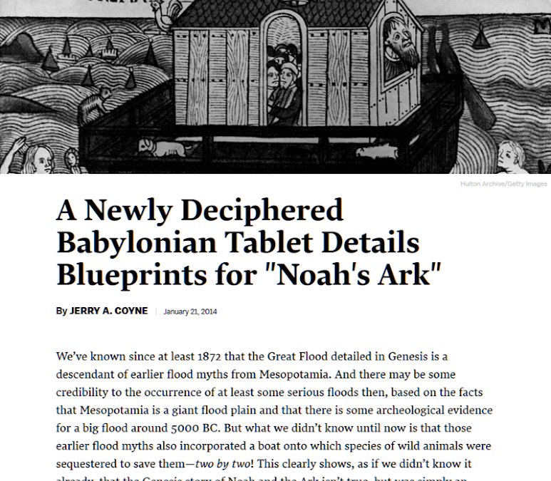](https://www.google.com/url?q=https%3A%2F%2Fnewrepublic.com%2Farticle%2F116287%2Fbabylonian-tablet-describes-noahs-ark-pre-bible&sa=D&sntz=1&usg=AFQjCNF9s0YCiueL4E3d4P1x5KGVq5Xd8g)

**Some more facts about the Bible:**

**Over and over science has proven the flood did happen.**

[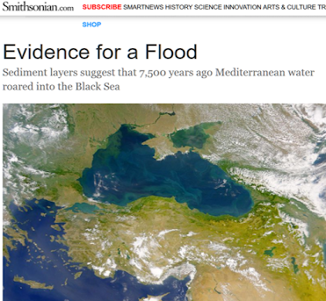](https://www.google.com/url?q=https%3A%2F%2Fwww.smithsonianmag.com%2Fscience-nature%2Fevidence-for-a-flood-102813115%2F&sa=D&sntz=1&usg=AFQjCNFL0kgmVR8UWWAediJq2SmaivYVDQ)

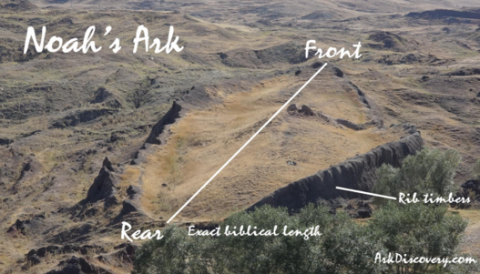

[Ron Wyatt's story and discoveries](https://www.google.com/url?q=https%3A%2F%2Fwyattmuseum.com%2Fdiscovering%2Fnoahs-ark%23&sa=D&sntz=1&usg=AFQjCNEbmZQKMX9VdIVgpV4Y6MJfZHl6IA)

**The lost civilization of the Hittites has been found.**

[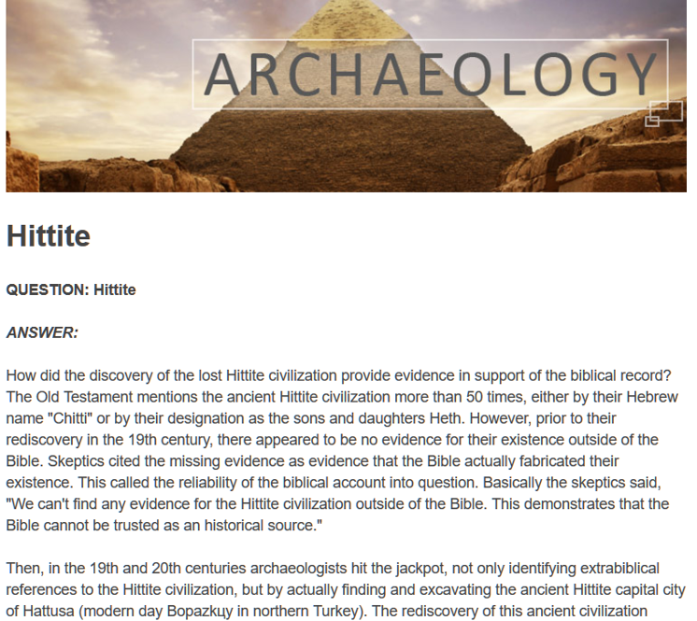](https://www.google.com/url?q=https%3A%2F%2Fwww.ancient.eu%2Fhittite%2F&sa=D&sntz=1&usg=AFQjCNGATqSspc1QM9UtcR8F8TOL4uvMxQ)

Mentioned over 50 times in the Bible

Bible Reference for the word Hittite

[](https://www.google.com/url?q=https%3A%2F%2Fwww.blueletterbible.org%2Fsearch%2Fsearch.cfm%3FCriteria%3Dhittite%26t%3DKJV%23s%3Ds_primary_0_1&sa=D&sntz=1&usg=AFQjCNF3T1RhpGrlDyZDfl3FRs4K9WC3MA)

**Sodom and Gomorrah have been identified.**

**They found 90% sulfur. That doesn’t exist anywhere else in the world.**

**Jericho found!**

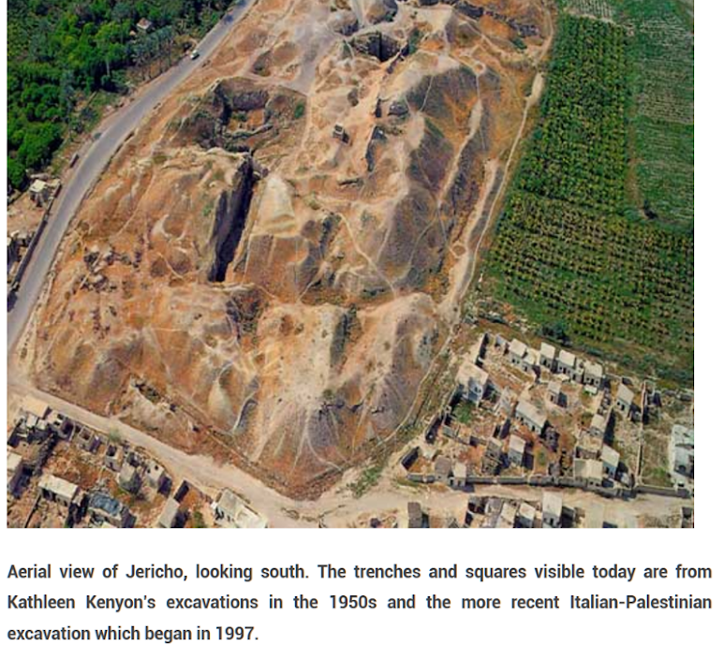

The remains of the city of Jericho have been found and the time of the Israelites' attack match its destruction.

[**Jericho**Jericho - Who inhabited this ancient city? What have the excavations taught us about its history? What about Joshua and the great battle?](https://www.google.com/url?q=https%3A%2F%2Fwww.allaboutarchaeology.org%2Fjericho-archaeology.htm&sa=D&sntz=1&usg=AFQjCNFdxPNY5czFX4oZWTAV5IqERzh4RQ)

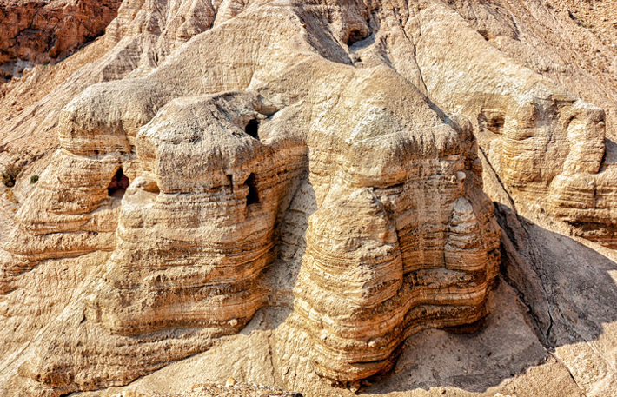

**The Dead Sea Scrolls**

When he investigated he found a multitude of clay pots containing scrolls. Several scrolls were intact, but most were fragmented. Many different people have spent years piecing together the fragments have as many scrolls as possible.

It was the Spring of 1947, when young Muhammed ed Di’b went in search of one of his sheep. The search took him through an area about a mile from the western shore of the Dead Sea. As he climbed around the steep cliff face, he noticed some caves. Instead of inspecting each one for his lamb, he picked up rocks and began tossing them in the cave. Instead of hearing a bleating lamb followed by the rustling of lamb feet, Muhammed heard a crash.

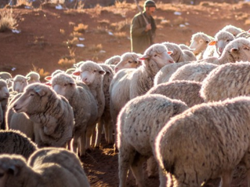

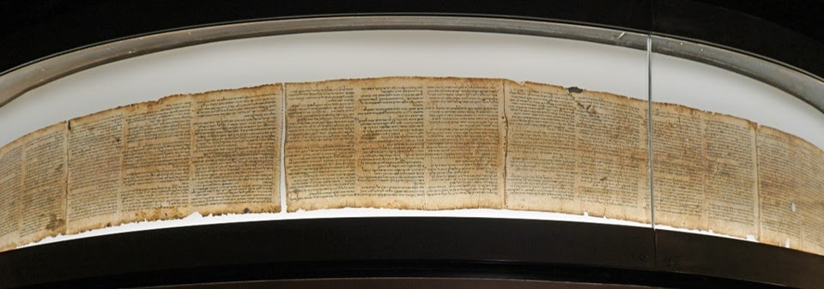

[www.imj.org.il/en/wings/shrine-book/dead-sea-scrolls](https://www.google.com/url?q=https%3A%2F%2Fwww.imj.org.il%2Fen%2Fwings%2Fshrine-book%2Fdead-sea-scrolls&sa=D&sntz=1&usg=AFQjCNFkcDZuDD6pw7I9um4C8zd8-_tl2g)

**Hebrew Voices #80 – Fake Dead Sea Scrolls Explained**

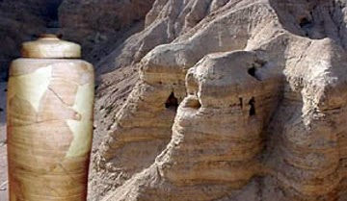

**Contained 2000 year old scrolls**

The Dead Sea Scrolls were discovered in a series of twelve [caves](https://www.google.com/url?q=https%3A%2F%2Fen.wikipedia.org%2Fwiki%2FCave&sa=D&sntz=1&usg=AFQjCNEB9JGJ0AKnWYWFTP7urdYa4e93jg) around the site known as Wadi [Qumran](https://www.google.com/url?q=https%3A%2F%2Fen.wikipedia.org%2Fwiki%2FQumran&sa=D&sntz=1&usg=AFQjCNHfmxSwolkYyhF94Ex0ZJdV9uxZZg) near the Dead Sea in the [West Bank](https://www.google.com/url?q=https%3A%2F%2Fen.wikipedia.org%2Fwiki%2FWest_Bank&sa=D&sntz=1&usg=AFQjCNFKZFeRPpVLQLoGtVdPFkyfqVSIjg) (of the [Jordan River](https://www.google.com/url?q=https%3A%2F%2Fen.wikipedia.org%2Fwiki%2FJordan_River&sa=D&sntz=1&usg=AFQjCNEQt4ybkIrx-paSTYgj1FrfLtHQTQ)) between 1946 and 1956

**Contained all the books in the Hebrew Bible but Esther**

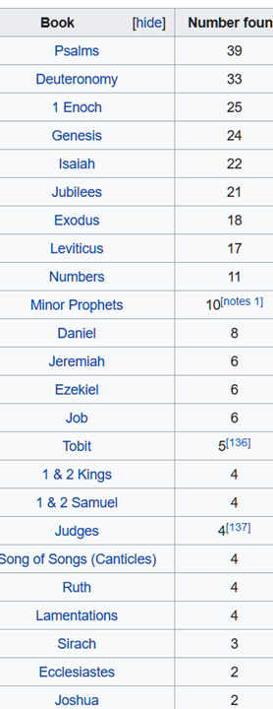

Of the 166 words in Isaiah 53, there are only seventeen letters in question. Ten of these letters are simply a matter of spelling, which does not affect the sense. Four more letters are minor stylistic changes, such as conjunctions. The remaining three letters comprise the word "light," which is added in verse 11, and does not affect the meaning greatly.

95% the same, exactly, word for word

This is a list of how many complete books of the Hebrew Bible were found in the 12 different caves. All of the books of the Hebrew Bible were found except for Esther. There were also many non-biblical books found. Such as the book of Enoch and the Apocrypha.

They found a 95% accuracy in the scrolls to match word for word as it appears in our Bible today. The 5% difference was due to a slip of pen or a difference in the spelling or translation of a word.

One example is the book of Isaiah 53 where they found out of 166 words only 17 letters were in question.

This proves without a shadow of a doubt for the past 2000 years God's hand has been on His word. Keeping it intact to say exactly what He wanted it to say.

**You can Google and look for the scrolls contents in read a majority of them for free online.**

[https://lh6.googleusercontent.com/KEV559GzGrVInOCpEvwr02AVF_iFaVbu63m3x6JmbcdmiqlMzQo6kiLSt8AvZ5IVk2kS7O_hGXY7I8PT8W57vCrZXZoEZULA3XSry0oNhKXcm5yNNLw=w371](https://www.google.com/url?q=https%3A%2F%2Fbiblestudy2go.com%2FBS2GO%2Flogin%2Findex.php&sa=D&sntz=1&usg=AFQjCNF_U4cYk9fy5dHd6JXS453QvCVNtQ)

[https://lh4.googleusercontent.com/9WJQ5ymLLUdXZJAMajBkzOXd8F-HSbzzrK2oaWHTtgqcXFtK8lf02cOEv9pQAupKf32jVvYYjWp6GF1j9eFv_ro4g2wBvWF0IpalzytI3UzMBXxEwA=w371](https://www.google.com/url?q=https%3A%2F%2Fbiblestudy2go.com%2Fvideo%2FHistory_of_Jesus-Chapter1-FINAL%2FHistory_of_Jesus-Chapter1-FINAL_player.html&sa=D&sntz=1&usg=AFQjCNH3JXJe8iaJJqfWMLvzI_kradTN1w)

[https://lh4.googleusercontent.com/W3lJ27-PVwsjFyCVAvUZt7tyFcmWzK9JSIoyr2eYSzvHkUQ2e1M7y-7m5-xzpoptyKpUhdRnKxQzQXHQRjoZ6fzd3Id61TUS4pOH8RXJnpaMNFcfIac=w371](https://www.google.com/url?q=https%3A%2F%2Fbiblestudy2go.com%2F&sa=D&sntz=1&usg=AFQjCNG3YO7S4l9myABEaBW9mHZICa_Kmg)

https://lh4.googleusercontent.com/Bk9CS6WXm_IUB4c5d1hpvyLBc2MO2617aWgQRrqTbitmU7RDaorpRicXA3DgScQRWQnXT-0p0r1g9OmZt2DGrgmL2llxfVWc4Diz1AeTQuXwnFm5ndI=w371