The History of Jesus

**Chapter 1 -**

**The Bible**

[https://lh5.googleusercontent.com/WLxKyxdNiKGynihWfZM70PTximDl3VhjXeDCQFab-NqLmp5CfwOm-QkuQEIz_5EJnP4O2iHjt0p9MeMWD9N5Mtn5qj4GJj_euHMj-nkk9JVXBm1bfnNM=w371](https://www.google.com/url?q=https%3A%2F%2Fbiblestudy2go.com%2F&sa=D&sntz=1&usg=AFQjCNG3YO7S4l9myABEaBW9mHZICa_Kmg)

[https://lh3.googleusercontent.com/QDqUwptLOUehTCS62K74KU9-eDMu0wOe9i7Ml9vvGPpw_49VaHDQ19Z2frIiQqp9jVCTOCZBHQhkD2DcdIWyfb2j-XJPlibwFu2-HQU4nUJ9Ie5mp9Q=w371](https://www.google.com/url?q=https%3A%2F%2Fbiblestudy2go.com%2Fvideo%2FHistory_of_Jesus-Chapter1-FINAL%2FHistory_of_Jesus-Chapter1-FINAL_player.html&sa=D&sntz=1&usg=AFQjCNH3JXJe8iaJJqfWMLvzI_kradTN1w)

[https://lh6.googleusercontent.com/EQnfvzf6kSnQk4BsPISGuLlqZV4bk5cSH1510J_IBymuX6uaD1mJbwIDH8hDfEX6-uKJ1mNcAyoqpvwbtIWgdWXaaIFCRJm3l13ihh89VaJWQ5ES2yc=w371](https://www.google.com/url?q=https%3A%2F%2Fbiblestudy2go.com%2FBS2GO%2Flogin%2Findex.php&sa=D&sntz=1&usg=AFQjCNF_U4cYk9fy5dHd6JXS453QvCVNtQ)

This is an e-Learning class for instructors. The points of the Bible Study will be presented with extra study tips and research to help the instructor to become familiar with the content.

Disclaimers

A few disclaimers: We're going to be studying the Bible and what the Bible has to say. We are not studying a specific religion or denominational teaching. We are not attempting to prove anybody right or anybody wrong. We're going to study the Bible and learn how to let the Bible interpret itself.

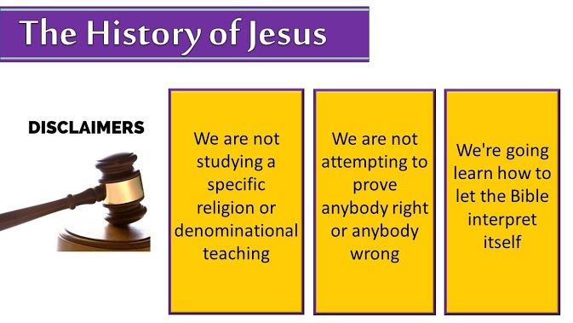

There are few rules for the Bible study. Number one we will not argue about anything. Open discussion and questions are welcome but arguing is not.

#1 We will not argue about anything

https://lh6.googleusercontent.com/PyslMx2EDLtTIsgDt6NGW0spO0F5D7PvIkHy7u1jbqxBdRRAUoXHtKdn-oxCjE0Oftq2Ud1Aok2ePdc-vX1bn5nNO3TzrPLO_bvdKJZgL8CeIuxUIg=w371

**2 Timothy 2:22-26**

22 Flee also youthful lusts: but follow righteousness, faith, charity, peace, with them that call on the Lord out of a pure heart.

23 But foolish and unlearned questions avoid, knowing that they do gender strifes.

24 And the servant of the Lord must not strive; but be gentle unto all men, apt to teach, patient,

25 In meekness instructing those that oppose themselves; if God peradventure will give them repentance to the acknowledging of the truth;

26 And that they may recover themselves out of the snare of the devil, who are taken captive by him at his will.

https://lh6.googleusercontent.com/Zlx0OUuTxjfuWpV0Y7aeIpKWeVpx8_tggqIj04nhDCv760MybRQ4SO1kp0P5qTKLUM4BlOPmmPQpqDSawx1ZlJKaHoK_FVdhn6BDqNkuNJWqtalequg=w371

**2 Timothy 2:22-26**

22 Flee also youthful lusts; but pursue righteousness, faith, love, peace with those who call on the Lord out of a pure heart.

23 But avoid foolish and ignorant disputes, knowing that they generate strife.

24 And a servant of the Lord must not quarrel but be gentle to all, able to teach, patient,

25 in humility correcting those who are in opposition, if God perhaps will grant them repentance, so that they may know the truth,

26 and that they may come to their senses and escape the snare of the devil, having been taken captive by him to do his will.

https://lh3.googleusercontent.com/SViEfOb8jWXpAoti5j-s5_TfqSzwcyeTzd2D0OGzQG5-mwSXXD7pVATKbxWlBD8IJ4IgttbHEIzyodmT8DnLKuSeUvnOhpFW4mwqJXNtDvamiY93UbRp=w371

**2 Timothy 2:22-26**

22 So flee youthful passions and pursue righteousness, faith, love, and peace, along with those who call on the Lord from a pure heart.

23 Have nothing to do with foolish, ignorant controversies; you know that they breed quarrels.

24 And the Lord's servant must not be quarrelsome but kind to everyone, able to teach, patiently enduring evil,

25 correcting his opponents with gentleness. God may perhaps grant them repentance leading to a knowledge of the truth,

26 and they may come to their senses and escape from the snare of the devil, after being captured by him to do his will.

https://lh3.googleusercontent.com/PTn04690u_U_MFCP3Lxo2A6Yf-P4Ohptgj1omrW0arW-D92rL0-X-oqiDRSnEY0SMJAkeQjZb2IBarRnUvcOC1Ms3GDjFAYJxxLTNc82pwV45k935HU=w271

**1. Follow ______________________, faith, charity, _____________, with them that call on the Lord.**

**2. A servant of the Lord must not ________________________.**

https://lh6.googleusercontent.com/SHre6Jkya7DqnJMZt1sSeNY7K-CC_qMj-XYtgbykO0Zh0rpuljfPRF-1xxUAokSKuvs9yRrxuO3mn0KgAM63y3mCr9jc9faKXINJW6d36gGNbR76YAXg=w371

Ecclesiastes 7:12

For wisdom is a defence, and money is a defence: but the excellency of knowledge is, that wisdom giveth life to them that have it.

https://lh3.googleusercontent.com/ORO_GM8n6iDeRwFqfvtpiCgAgubDulNa0QaxEjSiF8KrozS7z8Gm9o86Ah_qt2eEoCbcpBIxR8fpfKJIVCY9gCzDjFSliJBOhoEtxZB-55J2Buv86g=w371

Ecclesiastes 7:12

12 For wisdom is a defense as money is a defense,

But the excellence of knowledge is that wisdom gives life to those who have it.

https://lh6.googleusercontent.com/auCD4-__mDPqNbK4Of4aerfahaFcOrUaU99iM9T3xcupFVh2P22CRV8BPVcDzfKuVu8YTZSBypD6c4gqjbppntH5wsr8nImDh7AsRdRZX5SLFDdW3h7A=w371

Ecclesiastes 7:12

For the protection of wisdom is like the protection of money,

and the advantage of knowledge is that wisdom preserves the life of him who has it.

#2 There is no such thing as a stupid question

* + - * If you don't fully understand something research more or ask someone for help.

#3 Tradition does not mean truth

* + - * Just because you were taught this doesn't mean it's true. No matter if it was handed down from your great, great, great, great grandfather. If it cannot be found and proven in the Bible, it cannot be considered truth.

**Points to Remember**

You don't have to know every scripture there is on Salvation to be a good witness. But you do need to settle your questions about the Bible in your own mind.

Because if you walk around with doubts in your mind, you'll transfer those doubts to whoever you’re talking to. If they can't see that you believe and are comfortable with every word of the Bible, why should they believe Jesus’ gospel is true coming from you.

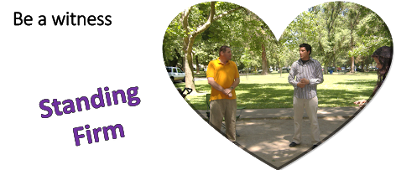

**Objectives**

https://lh4.googleusercontent.com/N9jBt7SRbZQAZkDfAL6yAyLbtX3W9Qvea2EMqxld4Sx5AxKg8wXoaFy6M6vGwicG0O4HnmjzLsdOcjtw6gxIrjqoyLFDJNpncWBNLGRH3BvDfI4Jcg=w874

* + - * + You need to know a group of good writers didn’t make this book. God did.

https://lh5.googleusercontent.com/a9ESpNYceARHtlnwO6rmgTlzt3FUWe6HOq4RUStq_h7Ey2jOKtg1HiCFcg3XfU1gqm1M7a7CuUYGaDkEueREF8B7zEE3q-W2HJ4XOnKh1h3mZgGb6Q=w874

* + - * + Why did God give us this wonderful gift? To teach us about Himself.

https://lh3.googleusercontent.com/8JNgJgD8ipFE2vIVz0018pMe1YHYTnh8svqGdlAp22tUs0frmlv6vKydck2bCRx7PERf4dQFeGpMVi4dYJltGAqqR33o2jjOQs1FjIvjM3vSIX18fsiY=w874

* + - * + You need a solid foundation to stand on. If you can’t be sure the Bible is really the word of God how can trust the plan of salvation?



The day may come when you are forced to stand in a court of law and testify that you believe the Bible is true. If you cannot stand firm on what you believe… you can be convinced you're wrong. In a court of law could you be found guilty for what you believe? Would there be enough evidence to convict you?

Every day we talked to people, who can tell by our words, if we have faith that what we believe is true. You can’t take someone else’s word for it. We must know within our own heart what YOU believe. We can't answer “my church teaches” we have to be able to answer, “I believe.”

https://lh4.googleusercontent.com/RAISMlx3jzUQzxqSD19WZMEwkcKkxej13hXyT2yw1CrJtidt5Rn1XxVNyV0piV2LKI3r-3f8mxbcxTdijXXHCeXneYufkMEsySWlBilJInSYG7yu6dQ=w371

Romans 1:16-20

16 For I am not ashamed of the gospel of Christ: for it is the power of God unto salvation to every one that believeth; to the Jew first, and also to the Greek.

17 For therein is the righteousness of God revealed from faith to faith: as it is written, The just shall live by faith.

18 For the wrath of God is revealed from heaven against all ungodliness and unrighteousness of men, who hold the truth in unrighteousness;

19 Because that which may be known of God is manifest in them; for God hath shewed it unto them.

20 For the invisible things of him from the creation of the world are clearly seen, being understood by the things that are made, even his eternal power and Godhead; so that they are without excuse:

https://lh4.googleusercontent.com/20HMBGxihLrCfVMHL41VrXXe3_6t-wteXUXu1O9X62oNwf785ZxS7FKm7wMzj3p1ZcR7noPMo3VV8nWWONmW_AsKCpwi4fV9INsBSnMoYrA6li3i8w=w371

Romans 1:16-20

16 For I am not ashamed of the gospel of Christ, for it is the power of God to salvation for everyone who believes, for the Jew first and also for the Greek.

17 For in it the righteousness of God is revealed from faith to faith; as it is written, “The just shall live by faith.”

God’s Wrath on Unrighteousness

18 For the wrath of God is revealed from heaven against all ungodliness and unrighteousness of men, who suppress the truth in unrighteousness,

19 because what may be known of God is manifest in them, for God has shown it to them.

20 For since the creation of the world His invisible attributes are clearly seen, being understood by the things that are made, even His eternal power and Godhead, so that they are without excuse,

https://lh5.googleusercontent.com/CVwlxWZ32lxDWu-u-CsGx4UkXNPsMsWA7sRhSTCJcfGo-7nrT1Nrb2yHKiwOu-2JidRLTe2o0-wYtFkyVRa2G-4FDFOFe0b7AirbYs478nGtQaQaPzo=w371

Romans 1:16-20

16 For I am not ashamed of the gospel, for it is the power of God for salvation to everyone who believes, to the Jew first and also to the Greek.

17 For in it the righteousness of God is revealed from faith for faith, as it is written, “The righteous shall live by faith.”

God's Wrath on Unrighteousness

18 For the wrath of God is revealed from heaven against all ungodliness and unrighteousness of men, who by their unrighteousness suppress the truth.

19 For what can be known about God is plain to them, because God has shown it to them.

20 For his invisible attributes, namely, his eternal power and divine nature, have been clearly perceived, ever since the creation of the world, in the things that have been made. So they are without excuse.

God gave us His word and He gave us the Holy Ghost to teach us. When we stand before the throne we will not have a valid excuse to offer as to why we were not a firm witness to the truth of God's word.

**3) In a court of law could you be found guilty for what you believe? ______________**



**As we walk through the Bible reading the stories of the real-life men and women following their lives as they succeeded or as they failed, we begin to see the nature and the personality of God and how He interacts with those who please him and those who fail him.**

We will now begin our walk through the Bible with a discussion of the structure and the breakdown of the Bible.

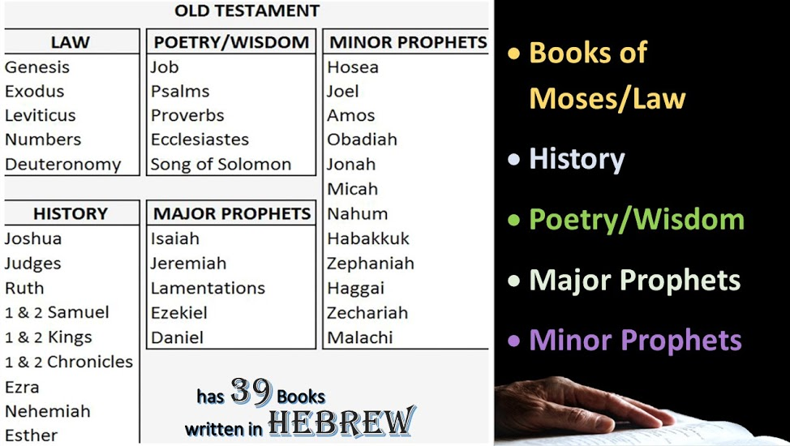

The Old Testament is the history of God’s dealings with humans from the dawn of creation until the time of Christ. The Old Testament has 39 books It was mostly written in the language of Hebrew. Daniel and Ezra were written in Biblical Aramaic.

* + - * Genesis to Deuteronomy is traditionally considered the books of Moses; also called the Law or the Pentateuch.
      * From Joshua to Esther are the Historical books
      * From Job to the Song of Solomon are the Poetical books
      * The Prophetical books contain the major and minor Prophets
      * The 5 Major Prophets are from Isaiah to Daniel
      * The 12 Minor Prophets from Hosea to Malachi

https://lh5.googleusercontent.com/Nvw0Hw60u2EXLBddgQkBH0IOHRj4Zs2WCHdsrBXUIi9jB3c66IAu8uQMd_2jEOALzLVaktsL3XTdjaVmaMa0ZnFsfVt73ErBxj60tDYsh3KL_NPSnWJM=w371

Hebrews 1:1

God, who at sundry times and in divers manners spake in time past unto the fathers by the prophets,

https://lh3.googleusercontent.com/A7L-LHXEcwPx3V-CU7B_Tpyglg2b_ZZYflGdhVy0K1zulUlzVcr_MAZQOSyi-c-mJly270i6Yon587JUtqu6Sp2AD_G7NP8omZNFEYdKN6YnlXSTc_s=w371

Hebrews 1:1

God, who at various times and in various ways spoke in time past to the fathers by the prophets,

https://lh6.googleusercontent.com/oektZS59_XL0RFrzerLHpeTfnpu7o-mCHg3Qc51O0cyWilViHDS9I21clisGhgj0RNWtyEMesFWvk7dBYn4iMu_Zlkh-iDtPg0sr1aWC_ZFXaQGTJA=w371

Hebrews 1:1

Long ago, at many times and in many ways, God spoke to our fathers by the prophets,

For the first 2500 years there was no written word of God. God spoke to man in different ways. He used angels, dreams, prophets, or donkeys if He had to. From the Garden to the Exodus. During this study we will talk about the major points of the Bible Timeline.

[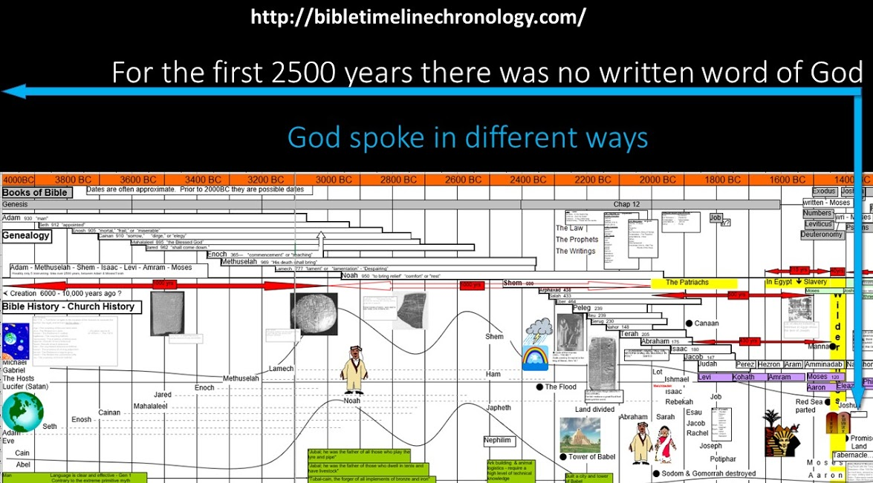](http://www.google.com/url?q=http%3A%2F%2Fbibletimelinesite.com%2F&sa=D&sntz=1&usg=AFQjCNHmmm9VezFoN5lCSoSo6cg3HEiAqg)

The first person we see in the story of the written word is Moses. The first 5 books of the Bible were written by Moses.

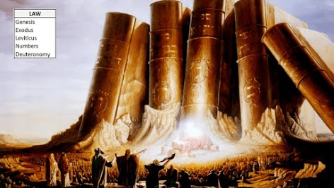

**There were witnesses that Moses talked to God!**

Moses took the elders of Israel up on the mountain to see God and to eat and drink with Him. These men were witness that God spoke to Moses face to face and that the Law was the words of God.

https://lh3.googleusercontent.com/Z5_ngYeIS28E997-SnL_cQ6qP7etI12NhTdJafcQqp2m3O5J5bauHtzpQ4OEILmfAFdFqZlogo6bs5w3Dksnxl0HhKtG-hauT1csCItj2yILEFyc2w7-=w371

Exodus 24:9-11

9 Then went up Moses, and Aaron, Nadab, and Abihu, and seventy of the elders of Israel:

10 And they saw the God of Israel: and there was under his feet as it were a paved work of a sapphire stone, and as it were the body of heaven in his clearness.

11 And upon the nobles of the children of Israel he laid not his hand: also they saw God, and did eat and drink.

https://lh3.googleusercontent.com/aT731BxBk_rZFmKOkK7_UrhsRO6qBeMvot0g8oSmXM8OYB_A8zvG5cCpgzV-r58_-0f5AIVNPJUJ9E82aHDI2UJ-tjmuRW0Vkahp263RTgEM-rI3ie7P=w371

Exodus 24:9-11

9 Then Moses went up, also Aaron, Nadab, and Abihu, and seventy of the elders of Israel,

10 and they saw the God of Israel. And there was under His feet as it were a paved work of sapphire stone, and it was like the very heavens in its clarity.

11 But on the nobles of the children of Israel He did not lay His hand. So they saw God, and they ate and drank.

https://lh4.googleusercontent.com/joh7haNtd64hGoSYKKD3giVNW3_ZM9XIWkRsw2TZ8Ion1g3_XmI3kOOxb2avbUfOK6S8i1gvm6EgtpLnUZp06dSSILhA4vghRKXHp-Pv_aVOiEX1gA=w371

Exodus 24:9-11

9 Then Moses and Aaron, Nadab, and Abihu, and seventy of the elders of Israel went up,

10 and they saw the God of Israel. There was under his feet as it were a pavement of sapphire stone, like the very heaven for clearness.

11 And he did not lay his hand on the chief men of the people of Israel; they beheld God, and ate and drank.

What they saw was a manifestation of the spirit of God. Notice it says they saw His feet and not His face. Notice the writer points out God didn’t kill them.

**In Exodus 31 God wrote His Law on the stone tablets Himself.**

https://lh5.googleusercontent.com/Hgrh4WDvYkqe7rnPTifalwdxJNt54_yfuieF_Wa2SyroFeOWZPxjY4VRZ6npx5kSgddAWqbWwW1ki7b-lY9ZM7SuRJ_ZNAaHPpLpqznGBrERLg5zzA=w371

Exodus 31:18

And he gave unto Moses, when he had made an end of communing with him upon mount Sinai, two tables of testimony, tables of stone, written with the finger of God.

https://lh3.googleusercontent.com/xS2PlynzvPREZewlc5TQJKMVczM2E2dapGbB2zExHTSZX04R-ctYZjr3qmAkhqv7cG-dnP-SWaaVXfQ4lXarIrVlM5urnkh1PuIVnwRvA6PhZ4kO5Yc=w371

Exodus 31:18

And when He had made an end of speaking with him on Mount Sinai, He gave Moses two tablets of the Testimony, tablets of stone, written with the finger of God.

https://lh6.googleusercontent.com/aGGrGeBOyNHVimiWfCupTQM3Xp1z483o1zgdJRXlL7rN5Nq5K8KE_F7lcn9AC8CQ0FB9hTvc5aKmUPa1Zdpk2Wi5MXnefe7M7Kn7_VaQdb_U44tgb3U=w371

Exodus 31:18

And he gave to Moses, when he had finished speaking with him on Mount Sinai, the two tablets of the testimony, tablets of stone, written with the finger of God.

https://lh6.googleusercontent.com/UDh0qHDd53CiD0wypDZeXfdFDfclw3NaB8fsUWrfNI9ElYTlRya5OEeLM8xzioAGrONU8R3wic33JLALnlYxBEZz7rvjTxUY-4bd7wRwO06kG_5dakI=w271

**4) Who wrote the Ten Commandment first? __________________**

**Moses says blot me out too!**

But when Moses came down off the mountain the children of Israel had made a molten calf and worshiped it. Moses threw down the tablets and broke them.

In chapter 32 God decides to kill all of the Israelites' and make a people out of Moses. Then Moses goes into the Tabernacle to talk with God. Moses says if you blot them out blot me out too.

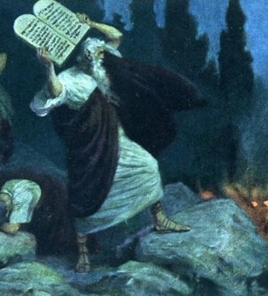

https://lh6.googleusercontent.com/QwcUzCMxoBQd3QB-6XcXFu8cqhletVKdnfkTDbVWXiKnrO98zJmafpmrS_-kmCtDeu98YCmWOPzWnbJ8hGF7P8_2pBOrVzYF9hytUuSnFGSR1mb3TdY=w371

Exodus 33:10-11

10 And all the people saw the cloudy pillar stand at the tabernacle door: and all the people rose up and worshipped, every man in his tent door.

11 And the Lord spake unto Moses face to face, as a man speaketh unto his friend

https://lh3.googleusercontent.com/WVPsZTiWFqPBXA7EXAeiCo7jO_lJ7bLHFFz-ZJMlvKjXa54Yk05KVft4lfBNk6ZAVhw6RR_ueTxoLwSghBjj8E3eO8hRGqgbvFT-4E_iiYVg5vCqaWnn=w371

Exodus 33:10-11

10 All the people saw the pillar of cloud standing at the tabernacle door, and all the people rose and worshiped, each man in his tent door.

11 So the Lord spoke to Moses face to face, as a man speaks to his friend.

https://lh4.googleusercontent.com/C3TYBGBRo50i3eDeqPccfCVisy2y_G7Hs1gFF8o4J4iaRmxhnskWp33Nfa2YuMsQoYDYYSzEb26hLSf2ll8bkEPafeDW8gjSyMl5bEzBTp3FT1fRu3A=w371

Exodus 33:10-11

10 And when all the people saw the pillar of cloud standing at the entrance of the tent, all the people would rise up and worship, each at his tent door.

11 Thus the Lord used to speak to Moses face to face, as a man speaks to his friend.

[Click to begin Lesson 2](https://sites.google.com/view/biblestudy2go-com/lesson-2)

[https://lh4.googleusercontent.com/NAh2t1ibm4TBlS17YBguuwErGea5l_tc4qVSjok6nAzwkXhxKan0mZB-QiUVeEN-rhxb1T2BRQ1G5WU49bllrXZHEOJKO8hKyGVotok11S9CGab2_bQ=w371](https://www.google.com/url?q=https%3A%2F%2Fbiblestudy2go.com%2FBS2GO%2Flogin%2Findex.php&sa=D&sntz=1&usg=AFQjCNF_U4cYk9fy5dHd6JXS453QvCVNtQ)

[https://lh3.googleusercontent.com/GMPz0J_BO483QMrRdfXyWtEdtJb-TbeJPjpF4PyicxzLXOeJY0xYwsuYefwaM1FWEXYRkXih3OduDDKDEwDRCc68O42xl7rlhzdVvRccLyKOdQMxKQ=w371](https://www.google.com/url?q=https%3A%2F%2Fbiblestudy2go.com%2Fvideo%2FHistory_of_Jesus-Chapter1-FINAL%2FHistory_of_Jesus-Chapter1-FINAL_player.html&sa=D&sntz=1&usg=AFQjCNH3JXJe8iaJJqfWMLvzI_kradTN1w)

[https://lh6.googleusercontent.com/xmqSTBZJZdYyuik3ZEnlE2ui9AUhqgEYtKxQzaqos9oz65xstQz0NDcarVQ5joBkXkQLOpTv-xLRwUieWvuqGfRXsOC29Dy2UWlQWVe4lfHdkBI12iU=w371](https://www.google.com/url?q=https%3A%2F%2Fbiblestudy2go.com%2F&sa=D&sntz=1&usg=AFQjCNG3YO7S4l9myABEaBW9mHZICa_Kmg)

https://lh3.googleusercontent.com/Wb5hUwfE9PivJqe8iE18EI3o7_gY6AD7-Yc7yOlN20yQryEl7WuUaYP7pzFP3dCYYyzCXcI3nmzyzuozpZVGlTbYsw7fkvAg73AQBaK4fSXgcwlHb1o=w371

Made with the new Google Sites, an effortless way to create beautiful sites.

Create a site

Report abuse