**Cleft of the Rock**

Lesson 2

[https://lh3.googleusercontent.com/T-NjzI9aaq3Pz2CmYQLrz6MePXUICD_HFrjplvvZOdsEKE4Hti81EP-2Du6fXyIRscWW3trtEu517dQSbS-RNIFKkRXkgcdFaOB9l9CdgOHAVwdOWcA=w371](https://www.google.com/url?q=https%3A%2F%2Fbiblestudy2go.com%2Findex.html&sa=D&sntz=1&usg=AFQjCNHG9StMNsno3_9lZf9Cf1Il5a8znA)

[https://lh4.googleusercontent.com/EbWVWWtFwlc_wJdN31D2z97uK9To_-aCXn4RNtYEuSFslY1qGwiYRe5KipHM6HnWpbFqYdff0ARkrjVvc_H0ykQYoJbfRz3GZiI-SPdsl4QDHKz5FLM=w371](https://www.google.com/url?q=https%3A%2F%2Fbiblestudy2go.com%2Fvideos.html&sa=D&sntz=1&usg=AFQjCNGEWFCzGis-mueSpz1D8pKfGS7__Q)

[https://lh3.googleusercontent.com/_rnfezxqC4ZfQZNNNHo7jxVaaiFVxVgEGN1Nv4Wtm9A3Wy3EGpwqzJqalP04VPIRqDtRNi_1u5ocx_Lz9Kfa1jnsflNKPHRKntv1ZexMK6i1_HoE4g=w371](https://www.google.com/url?q=https%3A%2F%2Fbiblestudy2go.com%2FBS2GO%2Flogin%2Findex.php&sa=D&sntz=1&usg=AFQjCNF_U4cYk9fy5dHd6JXS453QvCVNtQ)

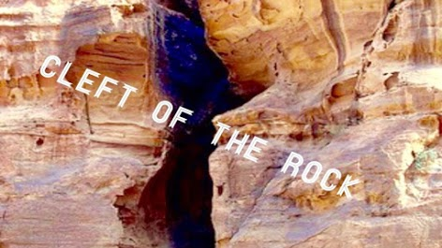

During this time with God Moses asks God to show him His Glory. God tells him that no man can see my face and live.

PERSONALLY, I believe God means not man can see His full plan for mankind to understand the Gospel. If He showed it to a man, the devil would know and try to stop Him. Thus, we have prophecy.

https://lh3.googleusercontent.com/F9SBr3hK_quEPM0EyyPTvVMcALXZhgvWhuHs_E9YHYFAsifV3BDr6C3lDzDDCHIn9lWEyUJU8CVbekIvETAe4Utetl0sVXxZz-_r7tiDaLUNbJ4W5Q=w271

**5) What did God show Moses while he was in the cleft of the rock? ________**

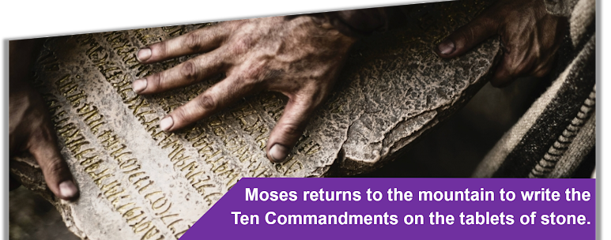

https://lh3.googleusercontent.com/47N4GFARdzS9-t_9ES2jT6QwD_t-nWGCgeKBWCgtMjSuBm69YxVn_fllnLvQDJGOnVsFMxaWxhBxNzH7kjpvhHZCCTu-CkK59qMKUX8A3iowrO_V_4M=w371

Exodus 34:28

And he was there with the Lord forty days and forty nights; he did neither eat bread, nor drink water. And he wrote upon the tables the words of the covenant, the ten commandments.

https://lh5.googleusercontent.com/VaSsng-t4VC8KASHattqiiX4LAA0Ku9UIhfO3ZuBMCRIY2PuWB2f2B343kytBSbHfxnOuiUEFoo6invJ-KQ2OVgKkIhCPV88vhcd0XjGwy0CThmeqLA=w371

Exodus 34:28

So he was there with the Lord forty days and forty nights; he neither ate bread nor drank water. And He wrote on the tablets the words of the covenant, the Ten Commandments.

https://lh3.googleusercontent.com/GaEWEaOUCnV-2qBb_A1kcaJebSa1aFcP643k50lQdBm1eFFODi9AuG_mnMGgX3iKyyriAbplW_ry7A4f4ET5c0DcUJ8OmZd4g3Z-YgOnxgxQruly2EA=w371

Exodus 34:28

So he was there with the Lord forty days and forty nights. He neither ate bread nor drank water. And he wrote on the tablets the words of the covenant, the Ten Commandments.

Moses wrote down all the law and the words of the Lord and told them to the priests and the 70 elders. The tablets of stone where placed in the ark of the covenant.

https://lh6.googleusercontent.com/BXTTiOyUskYdQM_OuxTndhlFhy3ivismysgEjLebfLFGyByJCnig_-rTJ5kNliWgQkVlg593MC1wSNu_0S7l9j2I-PjqIj6qnSm8fOZtf8eclf8qqGiz=w371

Deuteronomy 31:9-11

9 And Moses wrote this law, and delivered it unto the priests the sons of Levi, which bare the ark of the covenant of the Lord, and unto all the elders of Israel.

10 And Moses commanded them, saying, At the end of every seven years, in the solemnity of the year of release, in the feast of tabernacles,

11 When all Israel is come to appear before the Lord thy God in the place which he shall choose, thou shalt read this law before all Israel in their hearing.

https://lh5.googleusercontent.com/FmqjhAZH4i6ywcYhoTXbtEew8tajx_xCCuBoZyBPXoNs-SbTUdhdf21s225lOsMA2tA4xAmJINzt_XL3-y-jeIcfBAU8f4Vme--XHLJlaLR05lm5Pw=w371

Deuteronomy 31:9-11

9 So Moses wrote this law and delivered it to the priests, the sons of Levi, who bore the ark of the covenant of the Lord, and to all the elders of Israel.

10 And Moses commanded them, saying: “At the end of every seven years, at the appointed time in the year of release, at the Feast of Tabernacles,

11 when all Israel comes to appear before the Lord your God in the place which He chooses, you shall read this law before all Israel in their hearing.

https://lh6.googleusercontent.com/lPoKK-8gFCFsSqMIbgFASn6THhWv_zeROCPXKXwKKEyFA5qlXzKomHCLPtN4tnZp8bH9KAdFNHDzCFDGmcVqPfFMQZ_FHVJuUdrCSMgaD1YkWWnxxSg=w371

Deuteronomy 31:9-11

9 Then Moses wrote this law and gave it to the priests, the sons of Levi, who carried the ark of the covenant of the Lord, and to all the elders of Israel.

10 And Moses commanded them, “At the end of every seven years, at the set time in the year of release, at the Feast of Booths,

11 when all Israel comes to appear before the Lord your God at the place that he will choose, you shall read this law before all Israel in their hearing.

https://lh3.googleusercontent.com/f7eNwPoQkIiAIIvIljIKhLvEj3rZtXQBcM1nfeoytvh7YBAF-fIKDXKjagiCqKqvrX-KPDGUCYg4dDu9Q8L4AAEuA5EIyXMepmlj-CdcGrJNnCkC1cQd=w271

**6) How often did God say to read the books of the Law? ______________________**

God began to establish a written covenant

At this time God began to establish a written covenant that could be passed on from generation to generation. The Priest, Rabies and Scribes wrote on leather, clay and wood. Later they wrote scrolled paper. The Jewish priest are still writing the history today.

The Bible was not written in the order the books appear in the Bible today. It was divided by the translators and placed in an order that made sense to them. There are 40 different human writers of the books of the Bible. The Bible was “actually” written over a period of 1500 years.

The Old Testament covers a human life time period of 4000 years… after Adam and Eve left the garden. We are not actually told how long they were in the garden before they sinned.

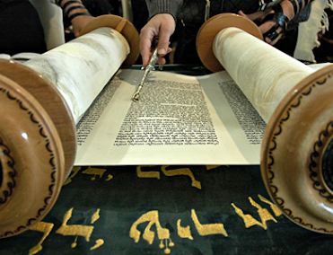

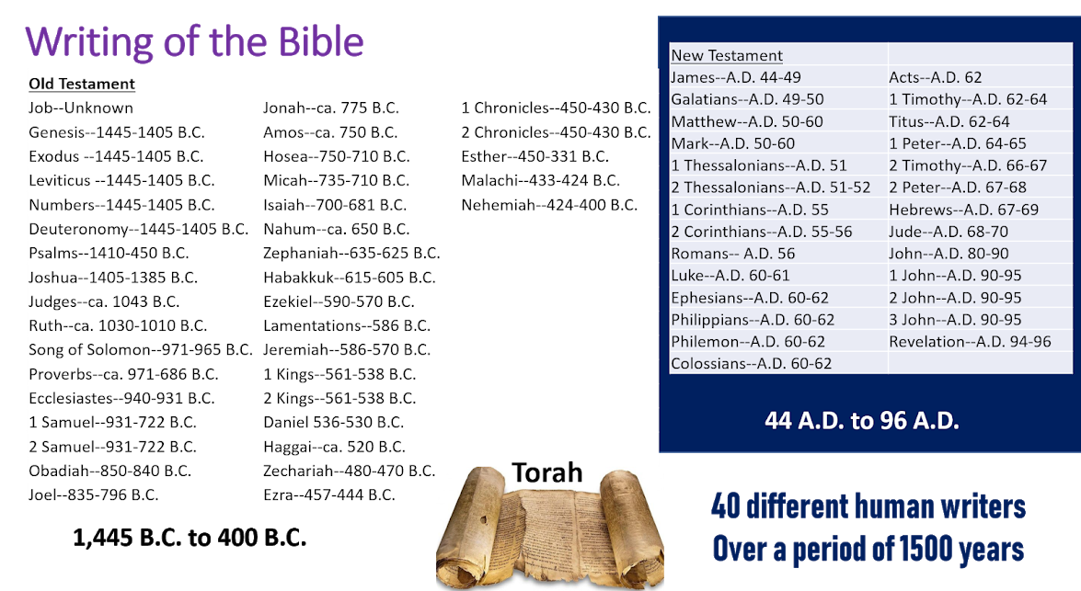

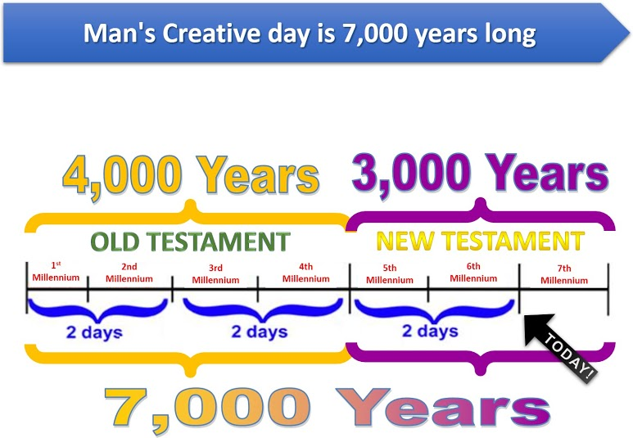

**The New Testament will cover 3000 years.**

2000 years for the church age and 1000 years for the millennium.

https://lh3.googleusercontent.com/Qs6jEOH6JJ8yBHOpy_CtlOC0uSU7p2kH8bDephFwf92gSQ1Elu3JRsLoyi8_Bn9ITuE4r07pMhy0Oa6aRX-csEh9Gy1WGEDeoP3wHczSycksPfgtng=w371

2 Peter 3:8

But, beloved, be not ignorant of this one thing, that one day is with the Lord as a thousand years, and a thousand years as one day.

Revelation 20:7

And when the thousand years are expired, Satan shall be loosed out of his prison,

https://lh5.googleusercontent.com/OyjPocesQLeshf7dFw4iTJIV5k-edms36RUxtpvEqdhwil5BUAvEmwz7yCl_OMY5h7M5Eegn6Oq7PQjCdNp1bdXA-2yjbvrmi1XvOVwhboqE8n7Qs20=w371

2 Peter 3:8

But, beloved, do not forget this one thing, that with the Lord one day is as a thousand years, and a thousand years as one day.

Revelation 20:7

Now when the thousand years have expired, Satan will be released from his prison

https://lh5.googleusercontent.com/sQ08cXok7n3JdFy8o9sddm_u600OePB_gARpmKOOzazSBTMyH02BzdArbCHATkVLIq3oLjLqXo6uldiB0p2djmgDOxyYtfGCBuIQ1ynJLF7ZaVkN0Q=w371

2 Peter 3:8

But do not overlook this one fact, beloved, that with the Lord one day is as a thousand years, and a thousand years as one day.

Revelation 20:7

And when the thousand years are ended, Satan will be released from his prison

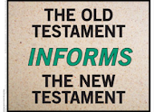

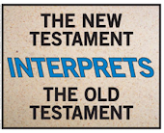

The titles of the OLD and NEW testaments came from the translators of the Bible. They also broke the books into chapters and verses. It was their way of helping us understand the Bible.

HOWEVER, the first 4 books of the New belong in the Old. The NEW covenant did not begin until after Jesus rose from the dead.

Never let anyone tell you the Old Testament isn’t important. God teaches us by physical or touchable things in the Old and what He wants us to see, be and do… in the Spiritual in the New.

https://lh3.googleusercontent.com/ccJfZbierqb2dpuKwze1aK15nEq_rZdVYluUDw2IxbZky32jEe9mlLpGK3GSV-Lje1oOXwoKfjMEU5QNUqEVK0mAqh441E3ptbZLGNKFPcMvDZUMdg=w271

**7) The Old Testament __________________ and the New Testament ________________________.**

[Click to begin Lesson 3](https://sites.google.com/view/biblestudy2go-com/lesson-3)

[https://lh4.googleusercontent.com/WSA_X9z0hVhqT2X7lrLxIAVLV19fR6xmMawllzfOizErvlnGiMRI1fAYxXNwy5IuXunLHAw3hVk_vV69dxqVpzWVlxFnRb4YPbV0VmqxzFJbWT0E-as=w371](https://www.google.com/url?q=https%3A%2F%2Fbiblestudy2go.com%2FBS2GO%2Flogin%2Findex.php&sa=D&sntz=1&usg=AFQjCNF_U4cYk9fy5dHd6JXS453QvCVNtQ)

[https://lh4.googleusercontent.com/QN4GJ7W-tuZ02jCuzDzQCz3nPKJHGdJ1lD-rHlHOb6JUeFALEJgqRrSjT4oRK-JT76LnbByc0KtmspulFMX4EbrIxsGS3bvnzds4EpqmikfzFHlo0g=w371](https://www.google.com/url?q=https%3A%2F%2Fbiblestudy2go.com%2Fvideo%2FHistory_of_Jesus-Chapter1-FINAL%2FHistory_of_Jesus-Chapter1-FINAL_player.html&sa=D&sntz=1&usg=AFQjCNH3JXJe8iaJJqfWMLvzI_kradTN1w)

[https://lh6.googleusercontent.com/7dgBqCkAefjGGfbdx2moQX4bTB253biXo9ZYhs9f8j914bDBJBOhQEbDtCrrUBWbw4R2sW2NySgMHp0hoGz6u1umFt0UBItCwC3eXYai3RuzrqoSASc=w371](https://www.google.com/url?q=https%3A%2F%2Fbiblestudy2go.com%2F&sa=D&sntz=1&usg=AFQjCNG3YO7S4l9myABEaBW9mHZICa_Kmg)

https://lh5.googleusercontent.com/m_zDkv389Uijir8u7HioFx81w38Mb7oJQUGzhg6jF0_V5UGRR93s6t6hixsAgZDSsmvdvpu5T9R6u2KnsKiTKNdShHZlbMLJFTJPscbnT4QGr4Fpksg=w371

Made with the new Google Sites, an effortless way to create beautiful sites.

Create a site

Report abuse