**The New Testament**

Lesson 3

[](https://www.google.com/url?q=https%3A%2F%2Fbiblestudy2go.com%2Findex.html&sa=D&sntz=1&usg=AFQjCNHG9StMNsno3_9lZf9Cf1Il5a8znA)

[](https://www.google.com/url?q=https%3A%2F%2Fbiblestudy2go.com%2FBS2GO%2Flogin%2Findex.php&sa=D&sntz=1&usg=AFQjCNF_U4cYk9fy5dHd6JXS453QvCVNtQ)

[](https://www.google.com/url?q=https%3A%2F%2Fbiblestudy2go.com%2Fvideos.html&sa=D&sntz=1&usg=AFQjCNGEWFCzGis-mueSpz1D8pKfGS7__Q)

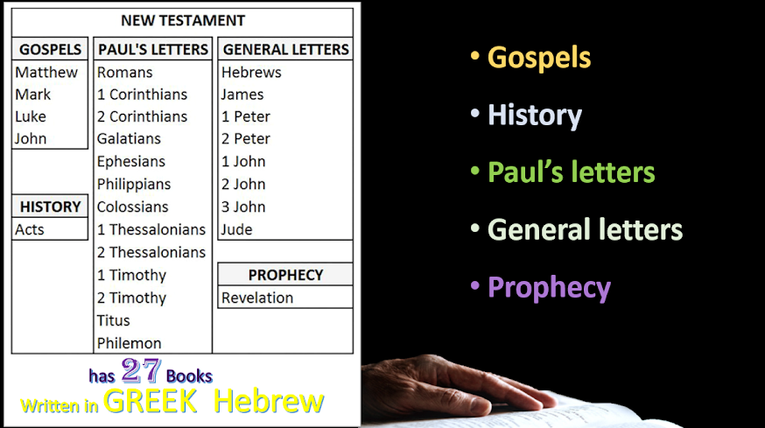

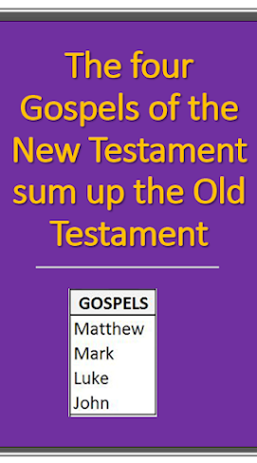

Jesus and the Apostles used the 39 books of the Old Testament

The four Gospels of the New Testament sum up the Old Testament. The Old Testament contained all of the types & shadows, the foretelling visions and the prophecies of the Messiah to come. The Gospels contain the proofs, to the Jews and the world, that Jesus absolutely was the Messiah.

Jesus and the Apostles used the 39 books of the Old Testament to prove and preach Jesus is the Messiah, our Lord and Savior.

The book of Acts is the history of what happened after Jesus died and the beginning of the church. The NEW TESTAMENT begins with the book of Acts.

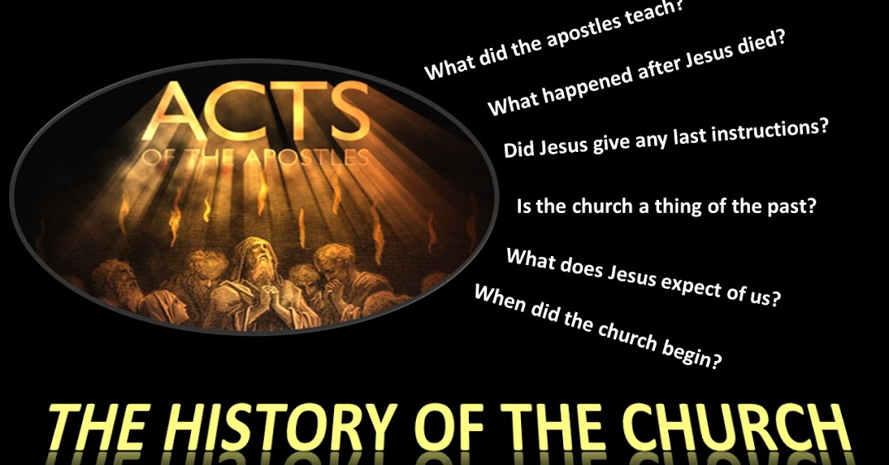

https://lh4.googleusercontent.com/HJWm-9G07rHWTtM_bB7BBB3_ujXztHg-vTCkrbKquYNZqOXlg4pcEyG5x5tjn92w1-DEl3XZHXkoZWsQSZapgUk0arJSsS4h_c_GoQAGPchCf1vFLv0=w371

Acts 28:28-31

28 Be it known therefore unto you, that the salvation of God is sent unto the Gentiles, and that they will hear it.

29 And when he had said these words, the Jews departed, and had great reasoning among themselves.

30 And Paul dwelt two whole years in his own hired house, and received all that came in unto him,

31 Preaching the kingdom of God, and teaching those things which concern the Lord Jesus Christ, with all confidence, no man forbidding him.

https://lh5.googleusercontent.com/s0TS2VoXgD5U75hqJmRbdKS8Q7uVpctHmBgZY6v98ihdkJIA_sJLf3eEVnmkiHov3CGgm0WwXLNEE9R8hguGcXMhg-I6zwmGlhb28fMalyTVGtKcRA=w371

Acts 28:28-31

28 “Therefore let it be known to you that the salvation of God has been sent to the Gentiles, and they will hear it!”

29 And when he had said these words, the Jews departed and had a great dispute among themselves.

30 Then Paul dwelt two whole years in his own rented house, and received all who came to him,

31 preaching the kingdom of God and teaching the things which concern the Lord Jesus Christ with all confidence, no one forbidding him.

https://lh4.googleusercontent.com/JL4u1nX-UYmQ3a2xLQVqolzJ02_mbkFhGRi22TZ-zJ9dZbSnxel4C9VG1UTLNee3_Ef0T5jU-Z46vwYXtidSOIXAbhMNUAA_7yFMXsgQNSpJCictvQ=w371

Acts 28:28-31

28 Therefore let it be known to you that this salvation of God has been sent to the Gentiles; they will listen.”

30 He lived there two whole years at his own expense, and welcomed all who came to him,

31 proclaiming the kingdom of God and teaching about the Lord Jesus Christ with all boldness and without hindrance.

https://lh5.googleusercontent.com/KX_hN-BMT6c6CCBqA-XsFjpg5fHWKCRuRLpyV7OsAIkVTMoDxN_2wvMsy0GSsbmZm1kOa6iy-nigcsq6KDXfIXlBThGalG5rZDU52LX2W0oIvMuNDTk=w271

**8) What is missing at the end of the book of Acts? ______________**

**9) Why? ________________________________**

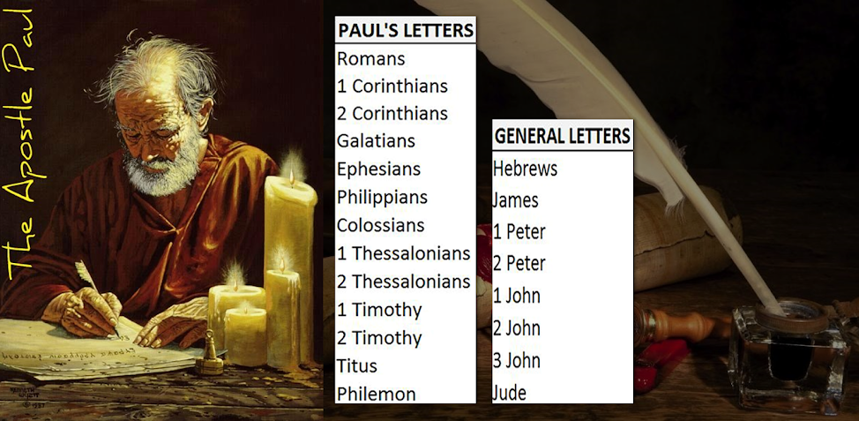

The majority of the New Testament was written by the Apostle Paul, to the various churches, he was the Bishop or overseer of. Most of Paul’s letters where written while he was in prison.

Next, we have the general letters written by James, Peter, John and Jude. Personally, I believe Hebrews was written by Paul also.

**The last book of the Bible is the book of Revelations.**



https://lh4.googleusercontent.com/5TGMRF2VIRVagjWXg2DT1IAQeNvHN9nuXBzzeMkgJEs4xgo8SMQavb6hczmtbsDeXSKXD0JD1DJcx8JMi8VQUNjRJAbWeyA9CPpAJdI1heT1574cXSG2=w371

**Vision of the Son of Man**

Revelation 1:9-11

9 I John, who also am your brother, and companion in tribulation, and in the kingdom and patience of Jesus Christ, was in the isle that is called Patmos, for the word of God, and for the testimony of Jesus Christ.

10 I was in the Spirit on the Lord's day, and heard behind me a great voice, as of a trumpet,

11 Saying, I am Alpha and Omega, the first and the last: and, What thou seest, write in a book, and send it unto the seven churches which are in Asia; unto Ephesus, and unto Smyrna, and unto Pergamos, and unto Thyatira, and unto Sardis, and unto Philadelphia, and unto Laodicea.

https://lh4.googleusercontent.com/FC2b0JBGNUii0DGLbMtbEl-eSwhfG5JZuMHJkUxpKEDAs55wV0hoyvDNN_IZemB1FDFoIkJFV0r8AtwRl4oXIaOADcbWP2W4hNKTAcAKEKYOEGggH4Yv=w371

**Vision of the Son of Man**

Revelation 1:9-11

9 I, John, both your brother and companion in the tribulation and kingdom and patience of Jesus Christ, was on the island that is called Patmos for the word of God and for the testimony of Jesus Christ.

10 I was in the Spirit on the Lord’s Day, and I heard behind me a loud voice, as of a trumpet,

11 saying, “I am the Alpha and the Omega, the First and the Last,” and, “What you see, write in a book and send it to the seven churches which are in Asia: to Ephesus, to Smyrna, to Pergamos, to Thyatira, to Sardis, to Philadelphia, and to Laodicea.”

https://lh5.googleusercontent.com/t0hO4ESHnlURFYmEt01Dq_RCYwq-T4WogqkaiYCvy2IkFwq1jsG5TjRKYQhKOi57Uigt5YhvbknIABVM4Uq7qSI4oRwK61DIjJoyUh6wgpdO9Fv4C8b7=w371

**Vision of the Son of Man**

Revelation 1:9-11

9 I, John, your brother and partner in the tribulation and the kingdom and the patient endurance that are in Jesus, was on the island called Patmos on account of the word of God and the testimony of Jesus.

10 I was in the Spirit on the Lord's day, and I heard behind me a loud voice like a trumpet

11 saying, “Write what you see in a book and send it to the seven churches, to Ephesus and to Smyrna and to Pergamum and to Thyatira and to Sardis and to Philadelphia and to Laodicea.”

**John had a servant who requested to go with him. As John was having the vision, the servant wrote what he was saying.**

[](https://www.google.com/url?q=https%3A%2F%2Fen.wikipedia.org%2Fwiki%2FJohn_of_Patmos&sa=D&sntz=1&usg=AFQjCNFnho7_4eP_6r8swoaEAdw5CspTfg)

[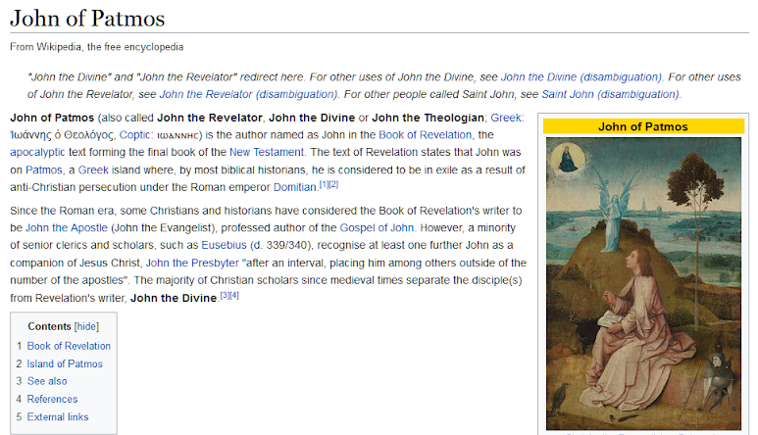](https://www.google.com/url?q=https%3A%2F%2Fen.wikipedia.org%2Fwiki%2FJohn_of_Patmos&sa=D&sntz=1&usg=AFQjCNFnho7_4eP_6r8swoaEAdw5CspTfg)

https://lh6.googleusercontent.com/mWUfEnB4APzqgMB9PSqyJuZcWpNW_zjA9ufY8BSmOeQQd8vHSaEFYSPPReAhHEXXH0Zj6Lk2YC2na6_31CnM2uC_eyiJgMJtkZLCQSPf7sw25DlVUPc=w271

**10) Where did John receive the book of Revelations? _________________**

[Click to begin Lesson 4](https://sites.google.com/view/biblestudy2go-com/lesson-4)

[https://lh4.googleusercontent.com/e3uUyHa5p38twhGiRK_pgddmsjtRZxWKRb_pH37r6-v3HCllBZOdDaVEA7_UX9A_L0xqZ04DCpgzc8NWbKDJFakEOB0fC_DTwvbYXSHbDbjN9blEnrY=w371](https://www.google.com/url?q=https%3A%2F%2Fbiblestudy2go.com%2FBS2GO%2Flogin%2Findex.php&sa=D&sntz=1&usg=AFQjCNF_U4cYk9fy5dHd6JXS453QvCVNtQ)

[https://lh6.googleusercontent.com/QueagUJJw4VzpzPPEaJ01EvUeuuny3hg9x3Y3V1q9hTgE7Fh7rNvbnl9NMwxKvgfkXpwZQkTtugyR739Y8wABsOkzeucmuEXqTwERLug1yxcblvLIQ=w371](https://www.google.com/url?q=https%3A%2F%2Fbiblestudy2go.com%2Fvideo%2FHistory_of_Jesus-Chapter1-FINAL%2FHistory_of_Jesus-Chapter1-FINAL_player.html&sa=D&sntz=1&usg=AFQjCNH3JXJe8iaJJqfWMLvzI_kradTN1w)

[https://lh3.googleusercontent.com/jvGBOxiZ8TfeY4Mks78rpF2_D2k1LIG9Jo_7KJHrl7w7iEnw_PUj00B0H4SlMTfUdh2blXClqLSNVq8gVAsAiSF9fCBa8mepWYA2vWFdfrU-oC290dk=w371](https://www.google.com/url?q=https%3A%2F%2Fbiblestudy2go.com%2F&sa=D&sntz=1&usg=AFQjCNG3YO7S4l9myABEaBW9mHZICa_Kmg)

https://lh6.googleusercontent.com/u0ajPiwMFFKMODuTcubcZjuLeTkJAk-0yGKMTXLzTTHaulgQSaxdzlFkPgm2PSpQ_RZDWCf1wdUKcxFQu9c5tl_gMimK850FJpn443lu_H--F8T0bbQ=w371

Made with the new Google Sites, an effortless way to create beautiful sites.

Create a site

Report abuse