**What About Jesus**

Lesson 4

[https://lh5.googleusercontent.com/6sM6GJYdKmlTRx9F6hVHW4008MvWMSqPNxjsRn4SGg_nY8Yfgt1kECi1WcSyeRPgVZue79dZOvePGOfwU63EAA1FWdNpoBCTI6An6YZQgxzPl4P7MZE=w371](https://www.google.com/url?q=https%3A%2F%2Fbiblestudy2go.com%2Findex.html&sa=D&sntz=1&usg=AFQjCNHG9StMNsno3_9lZf9Cf1Il5a8znA)

[https://lh6.googleusercontent.com/Ng5U2XZ-DPFUOSSPRwzY4k8-ghzD5UDS4qNQGLT73NxVGHxyEbznqysUYD0D56Kdgrcyk9BeG4_xVHuntzaEKg7DCTF9gqyOjYy2L5XLMyFnZ9fKMFE=w371](https://www.google.com/url?q=https%3A%2F%2Fbiblestudy2go.com%2FBS2GO%2Flogin%2Findex.php&sa=D&sntz=1&usg=AFQjCNF_U4cYk9fy5dHd6JXS453QvCVNtQ)

[https://lh5.googleusercontent.com/X7HMkRpz6tZWs9s7DGIaDrwkekyYTAvNUpWHm8159H4wJlaecWydJGEdmqFbJ4VxFakjPIs5nPiGVBh8SL06-ZCXEIE7gUIUrxvmVlFxcst-qkf79sc=w371](https://www.google.com/url?q=https%3A%2F%2Fbiblestudy2go.com%2Fvideos.html&sa=D&sntz=1&usg=AFQjCNGEWFCzGis-mueSpz1D8pKfGS7__Q)

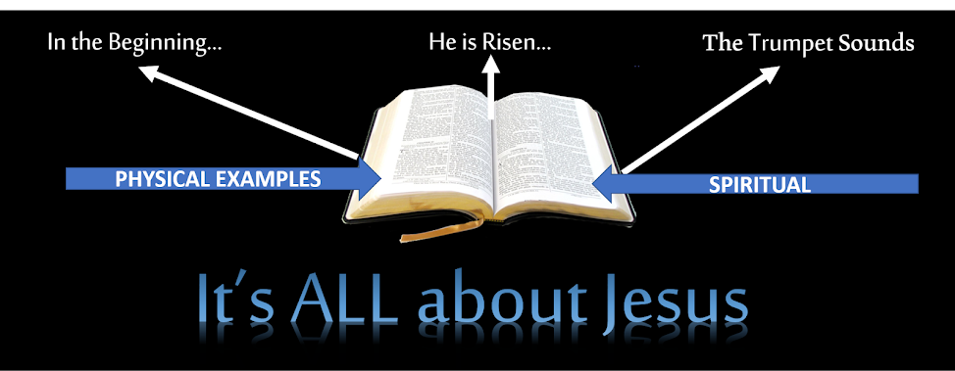

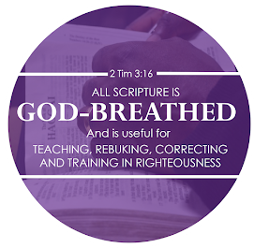

The entire Bible from “In the Beginning” to the last Amen of Revelations has all been about Jesus. In the Old Testament we are given the foundation of physical examples of what God expects of His children and His Bride. In the New Testament we are introduced to how to accomplish the things God expects from us in the spiritual.

All scripture came to us by the inspiration of God. It may have been pinned by humans, but it was ordained by God. Over 3,800 times the Bible uses the terms the Lord said, the Lord spoke, and God said.

https://lh6.googleusercontent.com/rvGwvF6r6x--AMehWNfpcc07YXUzOo6Z_0pcbC-bPVzojE0LJ-gtCtXIWhd1gUc6QNhenisknyKzAoyRWoM4BBUfuTgyopAmypdGuztprZHoLGJtsA=w371

2 Timothy 3:16-17

16 All scripture is given by inspiration of God, and is profitable for doctrine, for reproof, for correction, for instruction in righteousness:

17 That the man of God may be perfect, thoroughly furnished unto all good works.

https://lh5.googleusercontent.com/iS7PL0pi0Gi9NfiUluvE3O-XKhMjum3obnP0gLgQK9V4m2ZNZMo2SQP8HcJyZdtcXB-Eubshti4MF2BgvsLudYBBrywVi1BZsuPQ8t72a5dKio-eOaM=w371

2 Timothy 3:16-17

16 All Scripture is given by inspiration of God, and is profitable for doctrine, for reproof, for correction, for instruction in righteousness,

17 that the man of God may be complete, thoroughly equipped for every good work.

https://lh5.googleusercontent.com/hGBS6KJcCNE5jVKU1lbnCbYUt5p6H6gyknH0fiBmRg11AouSUJa4CCDQnXTCR5oldat1yyzR0j4ETv5XMJejpAlLM235fNI7Var6R5qFHrKdadBfSv4=w371

2 Timothy 3:16-17

16 All Scripture is breathed out by God and profitable for teaching, for reproof, for correction, and for training in righteousness,

17 that the man of God may be complete, equipped for every good work.

1 Corinthians 14:37

If any man think himself to be a prophet, or spiritual, let him acknowledge that the things that I write unto you are the commandments of the Lord.

1 Corinthians 14:37

37 If anyone thinks himself to be a prophet or spiritual, let him acknowledge that the things which I write to you are the commandments of the Lord.

1 Corinthians 14:37

If anyone thinks that he is a prophet, or spiritual, he should acknowledge that the things I am writing to you are a command of the Lord.

Jeremiah 30:1-2

1 The word that came to Jeremiah from the Lord, saying,

2 Thus speaketh the Lord God of Israel, saying, Write thee all the words that I have spoken unto thee in a book.

Jeremiah 30:1-2

1 The word that came to Jeremiah from the Lord, saying,

2 “Thus speaks the Lord God of Israel, saying: ‘Write in a book for yourself all the words that I have spoken to you.

Jeremiah 30:1-2

1 The word that came to Jeremiah from the Lord:

2 “Thus says the Lord, the God of Israel: Write in a book all the words that I have spoken to you.

There are many who know the Word but don’t know God!

You cannot separate God from His Word and you cannot know God without His Word. To study the Bible is not enough. You must study the Bible with a desire to know who God is. What was His plan? Why did He do all of this?

The more you desire to the know the more He will show you. God will reveal Himself to you.



**The Bible is the living Word…not a dead book.**

[Click to begin Lesson 5](https://sites.google.com/view/biblestudy2go-com/lesson-5)

[https://lh5.googleusercontent.com/AR-qzYG_OUSazTWJ6CWYspTDAA2eosMVl8Hqec-FOZxpnMfyB7-7rT0bhqZ2Oa9uHFNImIkOAw2BvlUK_Pus8y_A_PTmy_Hhm3NQpmvlFvcAqUz0X0E=w371](https://www.google.com/url?q=https%3A%2F%2Fbiblestudy2go.com%2FBS2GO%2Flogin%2Findex.php&sa=D&sntz=1&usg=AFQjCNF_U4cYk9fy5dHd6JXS453QvCVNtQ)

[https://lh4.googleusercontent.com/XzVY7cdklz5S4aCqJZowAKdXjYcb9dr8j1DswW8wTVpcs-O75ONKG74ofgmNnmhaWDXy9oajauYPRuiAb9ALL5ZnAGzf1iF0bodKQq3_VsYClkFLEA=w371](https://www.google.com/url?q=https%3A%2F%2Fbiblestudy2go.com%2Fvideo%2FHistory_of_Jesus-Chapter1-FINAL%2FHistory_of_Jesus-Chapter1-FINAL_player.html&sa=D&sntz=1&usg=AFQjCNH3JXJe8iaJJqfWMLvzI_kradTN1w)

[https://lh6.googleusercontent.com/c0JXNGz86XIfG9xOqUaU6aJwUFy41NbhmJ1TueEyB45Vcz8gekXuA-E3RHMS0XWY5-eOGuu0rbWoujRNSNwTpPUNt07JkXeQiQGqtLD3hyVJSQmTRPE=w371](https://www.google.com/url?q=https%3A%2F%2Fbiblestudy2go.com%2F&sa=D&sntz=1&usg=AFQjCNG3YO7S4l9myABEaBW9mHZICa_Kmg)

https://lh3.googleusercontent.com/9QxiZtdp9cJ6x-cWs9vQ2Srmg_ZNT33bp7VV2kYzxS_9dEN_WfVVjBDC3-MCvNlu0UUU3EedxJFWDLjzPD0hVfubz7OxKN42-8IHTMzVAu10vk3agh0=w371

Made with the new Google Sites, an effortless way to create beautiful sites.

Create a site

Report abuse